**Bill of Materials**

Blue acrylic 12x 24’ from mcmaster

Clear acrylic 4- 3x18”, 4- 3x 36”,2- 18x36” from mcmaster

Card stock-12x24 from blick

Plywood 8- 12x 24 1/8” thick from blick

Fan amazon

HPDE 2- 12x24 from mcmaster

80-20 1” Extrusion from mcmaster

3D printer from epic

Laser cutter

3 axis CNC machine

Lathe

SolidWorks

Drill press

Hand mill

Colored filters

Pv panels

12V AC-DC converter, 1A supply x 2

6V Solar Panel x2

**Power Sequence**

Each module uses its own circuit, power supply, power strip, and a Raspberry Pi. The energy efficiency and wind module circuits can be powered by plugging in the included 12V supply. The solar module uses solar panels to drive the circuit. Turning on the module’s lamp is enough to drive the visual load. The last module, Smart Grid, is completely powered by a Raspberry Pi. The 3.3V pins are able to drive each quadrant of LEDs.

**Circuit Schematics**

Please refer to Git resource.

**Overall Project Setup**

The SWEET City exhibit is split into four modules. Two sets of aluminum extrusion frames confine two modules each. The Solar and Wind modules share one frame while the Energy Efficiency and Smart Grid modules share the other. All project circuitry and processing hardware are confined by acrylic inside the aluminum box. Each set of modules includes a power strip to plug in all electronic hardware required for the project.

**Solar Module Setup/Use**

Once the module’s lamp and raspberry pi are plugged into the included power strip, the user is able to vary a visual load by adjusting solar output. Two solar panels, wired in series, drive an LED strip mounted inside a small scale model of the National Grid LNG Tank in Dorchester. The user can place light filters between the lamp and solar panels to simulate different weather patterns. As the filters change, the load will brighten or dim.

**Wind Module Setup/Use**

The Wind module requires a 12V DC supply to drive a summing amplifier (see git resource.) After plugging this 12V supply and the raspberry pi into the power strip, the user is able to view power generated by one of the module’s wind turbines. The customer is able to change turbine blades to see the effect of blade type on power output. The module simulates power output using a rotary encoder and summing amplifier. The raspberry pi measures rotation frequency of the turbine blades. Pin voltages are applied to a summing amplifier which light a small scale model of the iconic Citgo Sign in Kenmore Square.

**Energy Efficiency Module Setup/Use**

The energy efficiency module contains a switching circuit mounted on a printed circuit board. The circuit board is wired to two push button switches as well as three incandescent bulbs and three LEDs used as stadium lights in a model of Fenway Park. Plugging in the included 12V DC source powers the board. The user is then able to press the push button switches to supply power to the incandescent and LED lights. A raspberry pi is connected to each switch set and can tell when the switches are toggled. The raspberry pi then displays power consumed on the module’s LCD screen.

**Smart Grid Module Setup/Use**

The Smart Grid module uses a printed circuit board comprised of four quadrants of LEDs. A raspberry pi plugged into the included power strip supplies power to the LED quadrants. The user is able to trigger a blackout by creating a fault point in the transmission line strung across the module. When the user separates the male wire from the female wire in the transmission line, power is cut from the LEDs and then rerouted to relight the lights. Once three of the four quadrants are lit, the raspberry pi waits for the user to reconnect the wires. This turns the final quadrant back on and resets the 7 inch module display.

The smart grid display, unlike the three others, is slightly more interactive. It displays the total number of customers in the model city and the number of customers that are without power at the time. The display also shows a summary of the entire project, giving values such as the city’s renewable contribution.

**Printed Circuit Board Images**

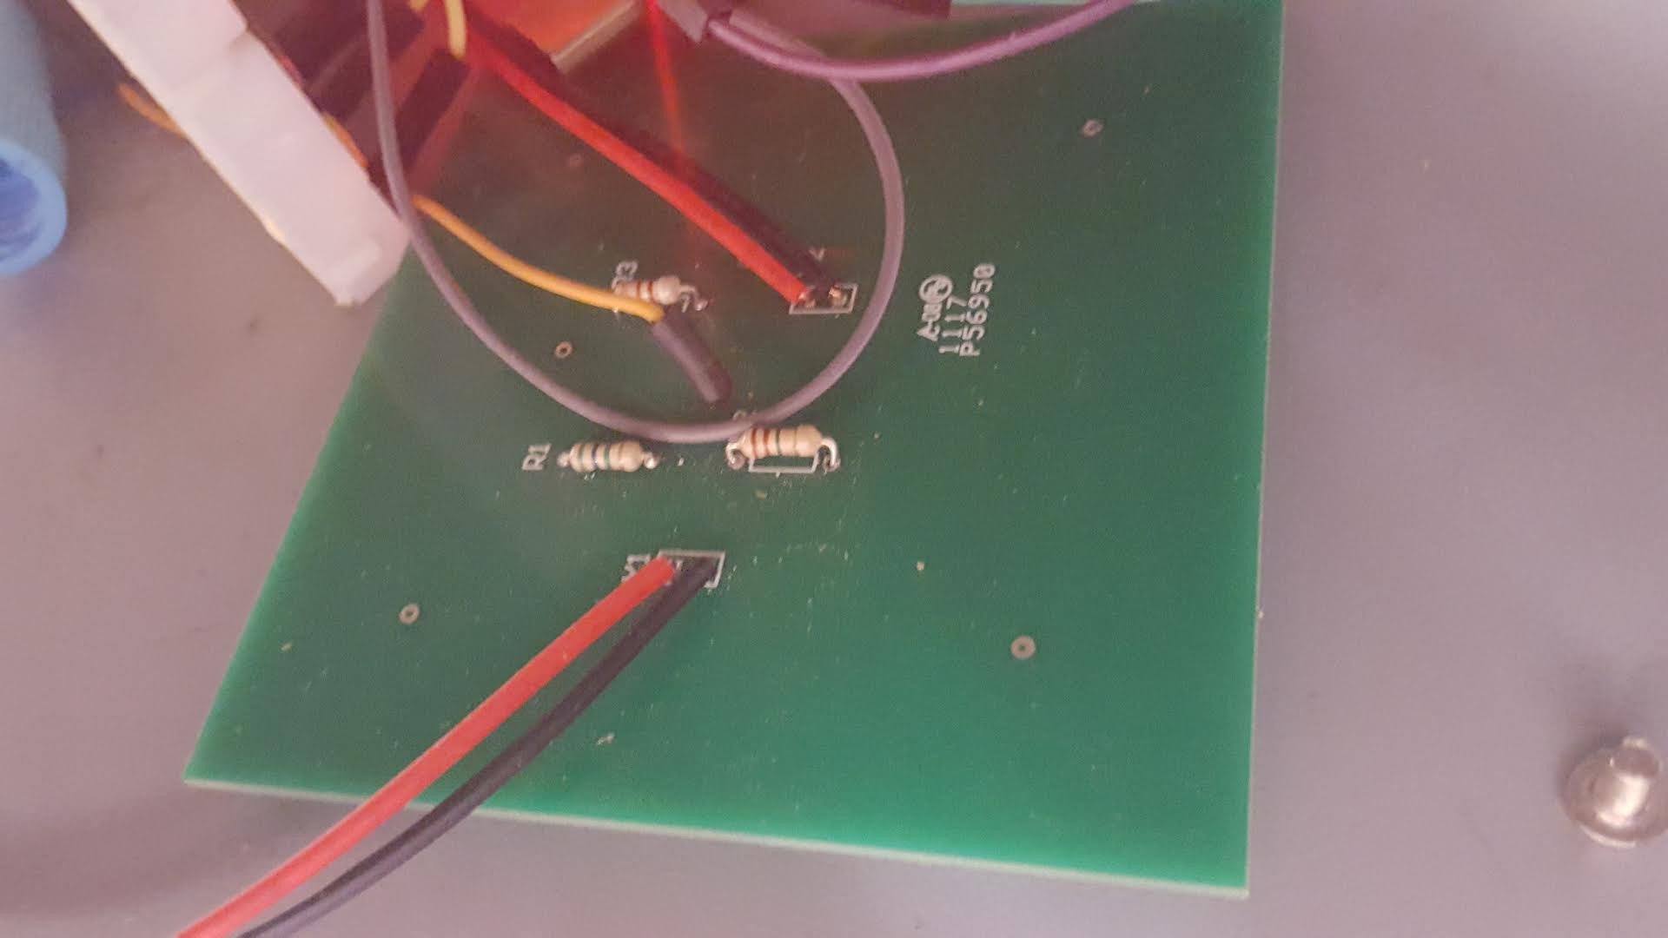

**Figure 1**

Figure 1 shows the printed circuit board for the solar module. The red and black wire connection at Y1 shows the solar panel connection to the entire board. The orange wire is a voltage measurement for the raspberry pi. This allows for power to be displayed on the module’s LCD. Red and black connection at the top of the image, Y2 is a connection to the module’s visual load.

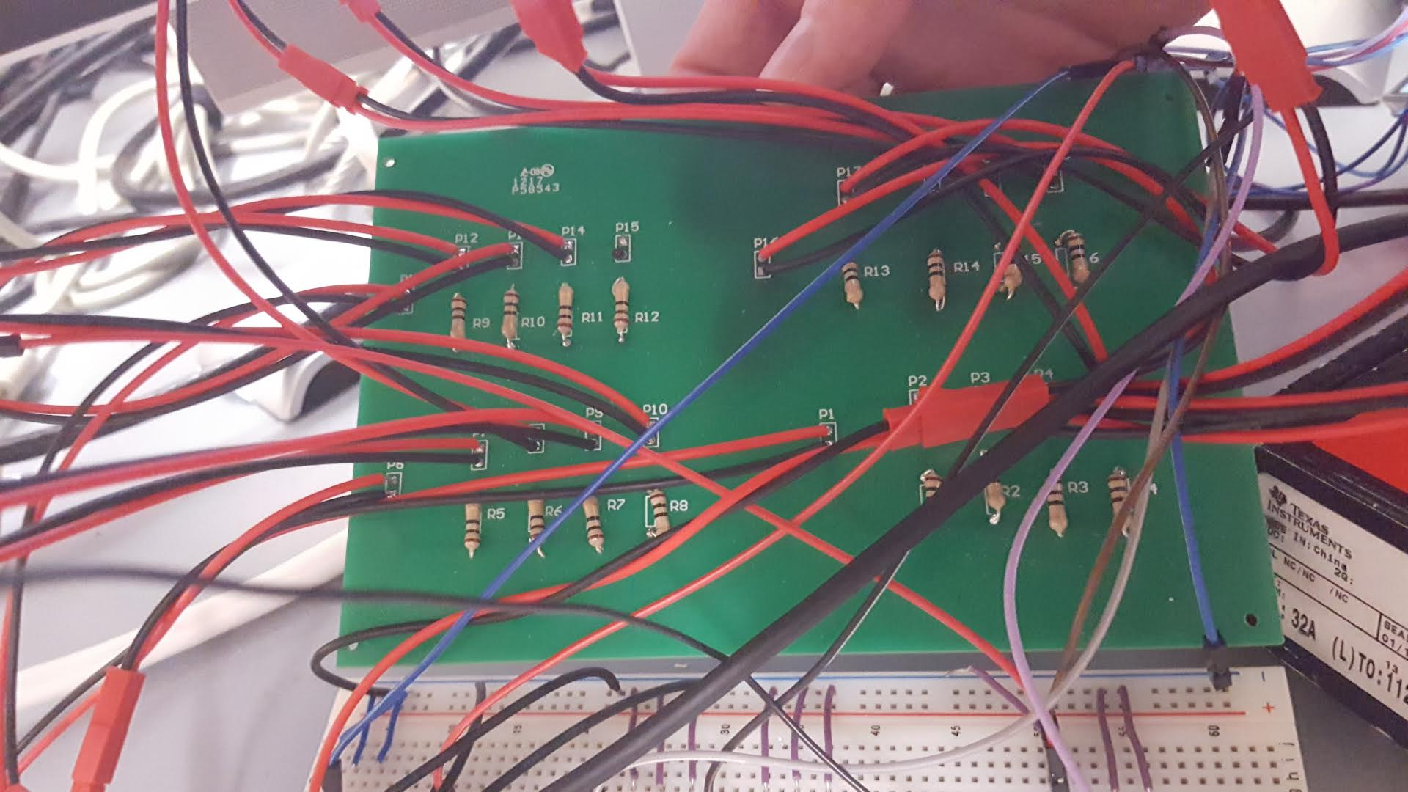

**Figure 2**

Figure 2 shows the printed circuit board for the Smart Grid module. Each set of red and black wires is a two pin connector to the four LED quadrants on the board. Each quadrant has a connector to a 3.3V raspberry pi pin as well as 4 connectors to LEDs on the module.

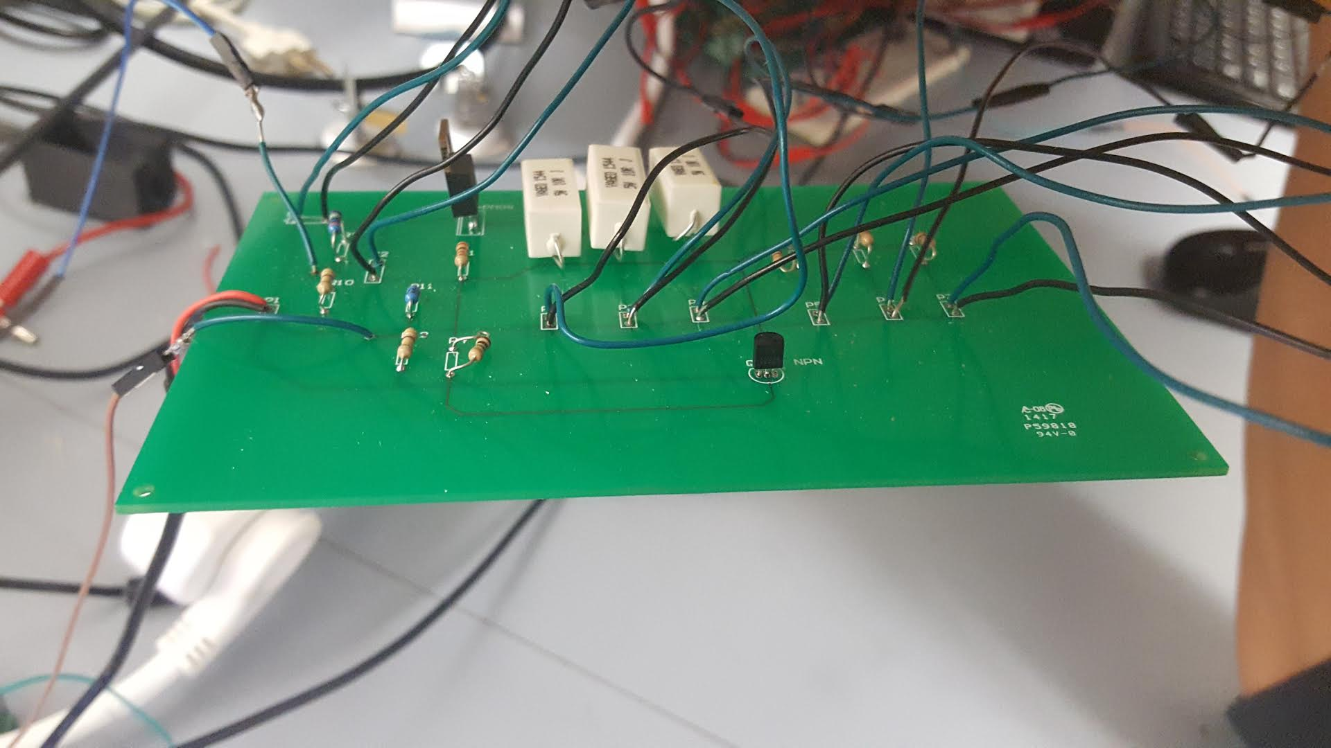

**Figure 3**

Figure 3 shows the energy efficiency PCB. The set of red and black wires to the left of the board is a two pin connector attached to a 12V DC supply. The sets of green and black wires are soldered to switches or the incandescent and LED loads.